**Additional Changes:**

* You are able to pick both pick-up and delivery. Currently you may only select one. Please have it so it is possible to select both.
* Also, on switching yes for delivery, extra options appear. Do you lay this out or our developers?
* Can’t switch back from no to yes. They get stuck. Each toggle should be able to be turned from yes to no, independent of the other ones.
* There is now a fourth way to receive orders – Via Manager Tablet. The icon for this is included on FileZilla under signup/updates0202

Under “Complete Your Set Up” , we need to add the area for plan selection and payment details.

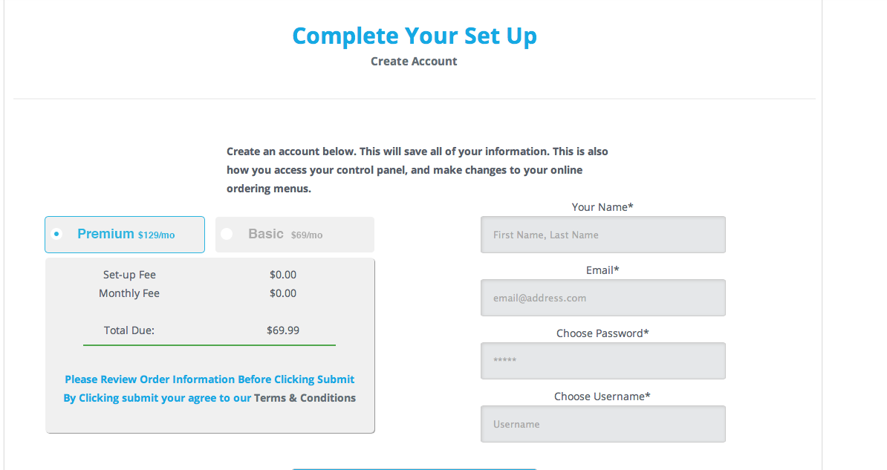

* The Premium package should be the default selection.
* They may switch to the other package by selecting the radio button.
* There needs to be a tooltip for both plans, with what they include (in column form)

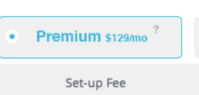

* + **Premium:** *Orders via fax, POS, email*
  + *Unlimited orders*
  + *Confirmation phone calls*
  + *Mobile-ready site*
  + *Powerful order analytics*
  + *Credit card integration*
  + *E-coupon creation*
  + *Facebook ordering*
  + *Cloud control panel*
  + *Free Manager's Tablet*
  + *Online reputation management*
  + *Text message ordering*
  + *Review boost*
  + *PowerListings™ via Yext*
  + **Basic:** *Orders via fax, POS, email*
  + *Unlimited orders*
  + *Confirmation phone calls*
  + *Mobile-ready site*
  + *Powerful order analytics*
  + *Credit card integration*
  + *E-coupon creation*
  + *Facebook ordering*
  + *Cloud control panel*
* Below the total, there should be fields for submitting their payment information. Credit card #, name on card, cvv and billing address.
* The “Save” button can be changed to say “Submit.” We will only have the option to either submit the form, or go back. The “Save” option is being removed.

